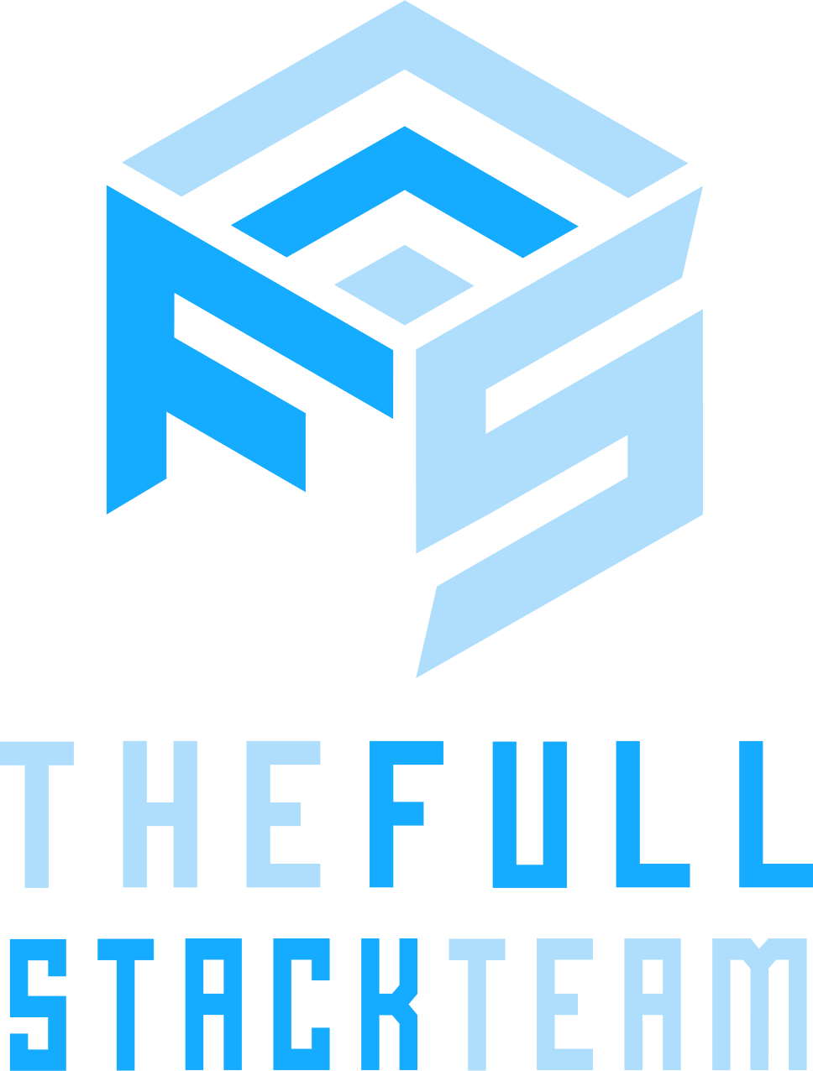

Juan Carmona

+34 687 344 436

2842, Madrid, Spain

**DIPLOMAS Y HOBBIES**

**Formaciones :** Diplomados, Congresos, xxxxxxxxxx xxxxxx xxxxxxxxx xxxxxxxxxxxxxxxxx

**Hobbies:** xxxxxxxxxxxxxxxxxxxxxxxxxxxxxx



ceo@thefullstackteam.com

**PROFESSIONAL**

**SUMMARY**

**Super Senior Consultant. CEO. CTO.**

Software engineer; Cloud Architect; 15+ years of software development experience in various industries, including rail, aviation, healthcare, insurance, and IT services.

* **Technical**

Development Tools: Visual Studio, Visual Studio Code, Android Studio, .NET Framework, .NET Core, .NET 6, Xamarin, MediatR, Angular, RxJs, NgRx, Azure IaaS, Azure PaaS, Azure SaaS, Azure DevOps, Active Directory, Azure AD B2C, Microsoft Entity Framework, RabbitMQ

Programming Languages: C#, TypeScript, JavaScript, HTML, CSS, SCSS, Power Shell, C, C++, Objective-C, Python, Java, Kotlin, Scala, Haskell

Web & Application Servers: IIS, IIS Express, NodeJS, Kestrel

DBMS: Microsoft SQL Server, Azure SQL Database, Azure Cosmos DB, Redis, MongoDB

Operating Systems: Windows, Mac OS X, Debian, Ubuntu & many other Linux distributions

Other Tools: Git, SVN, Microsoft Visio, Draw.io, VMware, VirtualBox

**SKILLS**

* **Design**

Data Modeling and Databases

Data Modeling and Databases

Microservices Architectures

Domain Driven Design

SOLID Principles and Design Patterns

Large Scale Distributed Architectures on Premise and on Cloud

Microservices

Microsoft Azure Cloud Technologies

Software Architecture Design

Software Development

Stream Processing

* **Industry**

Tourism

Automotive

Railway

Retail

Aviation

Healthcare

IT

* **Soft**

Leadership, Vision, Communication, Problem Solving, Creativity, Teamwork, Organization under Agile Principles, Adaptability

**LANGUAGES**

**EDUCATION**

**/TRAINING**

**05/2015:** Master of Science - Computer Science – University of xx - City- Country

**05/2013:** Bachelor of Science - Computer Science – University of xx - City- Country

**English:** Advanced (Speaking Proficiency); Advanced (Writing Proficiency)

**Spanish:** Native Speaker (Speaking Proficiency); Native Speaker (Writing Proficiency)

©AZURIUS – Modelos-de-curriculum.com

**WORK**

**HISTORY**

**CERTIFICATION**

* **2020:** Professional Scrum Product Owner I - Scrum.org
* **2020:** Confluent Certified Developer for Apache Kafka - Confluent Inc.
* **2020:** Confluent Certified Operator for Apache Kafka - Confluent Inc.
* **2020:** Segment Analytics Certification - Segment University
* **2020:** Segment Implementation Certification - Segment University
* **2019:** AWS Solution Architect Associate - AWS
* **2017:** Cloudera Services Enablement Bootcamp - Cloudera Inc.
* **2016:** Professional Scrum Master I - Scrum.org

*04/2019 - PRESENT*

**Tourism** Spain

***Founder, CEO & CTO*** Logtrip S.L.U.

Logtrip is and Adventure Travel Marketplace that links adventurers and nature lovers from all around the world with local travel agencies and professional guides which credentials and professional qualifications have been proven.

As a CEO I have funded the company, defined a profitable business model, key relationships, and managed project goals, objectives, timeline, and budget. I have guided a multidisciplinary team which included financial, operations, business development and marketing managers. As a CTO I have designed a cloud architecture as well as a development lifecycle according to a well-defined DevOps culture based on agile methodologies. I have also led a small team of full stack developers providing techniques, designs, and experience in backend software architectures with .NET Core tools and framework and frontend best practices with Angular.Technologies used: .NET Core, MediatR, Domain Driven Design, CQRS, Entity Framework Core, Angular, NgRx, Microsoft SQL Server, Azure, Azure AD B2C, Azure Storage, Azure DevOps, Scrum

*09/2019 - 09/2021*

**Software consultancy** Spain

***Software Team Lead*** WayOps

Analise Software requirements and design systems and solutions based on .Net, .Net Core, Angular. Provide web and mobile application development services as well as Azure and Azure DevOps training and mentoring, including cloud architectures, Serverless techniques as well as SOLID principles, Design patterns and Software Architecture.

- Give technical guidance, trainings and mentoring about those technologies and techniquesTechnologies used: Azure, Azure AD B2C, Azure Storage, Azure DevOps, .NET Core, MediatR, Domain Driven Design, CQRS, Angular, SOLID Principles

*11/2017 - 03/2019*

**Automotive** Spain

***Software Development Engineer***    
***& Technical Development*** Solera Global Data & Content

* Give technical guidance to current Development Team
* Select new team members to join VIN Development Team based in Madrid
* Manage VIN (Vehicle Identification Number) Service Legacy Code:
* Create proper UML documentation and update it during project evolution
* Give refactoring guidance
* Increase code coverage to be prepared for potential refactoring issues
* Adapt the code to meet .NET Code standards
* Adapt the code to meet SOLID principles
* Propose architectural improvements to be implemented gradually
* Modernize technology stack in order to be able to evolve to a micro-services-based architecture by migrating VIN Server modules to .Net Core based micro-services
* Encourage a DevOps philosophy within the team improving current CI process and proposing a CD pipeline.Technologies used: AWS, Apache Kafka, Apache Hadoop, Apache Spark, Python

*07/2006 - 10/2017*

**Railway** Spain

***Software Architect*** Alstom

Responsible for the design and architecture of Mastria, the Alstom's Smart Mobility solution. Mastria was designed to answer transport authorities’ need to operate several transport modes in a centralized and coordinated manner. It is an innovative multimodal system, which aims to streamline urban transport management by improving capacity and fluidity. More info here: <http://www.alstom.com/products-services/product-catalogue/rail-systems/signalling/products/mastria-multimodal-solution/>

Technologies used: .Net Core framework, Microservices with Docker, RabbitMQ, Visual Studio 2017, Visual Studio Team Services, Scrum and Agile, Angular 4+, Xamarin and many others

*10/2014 – 06/2006*

**Railway** Spain

***Senior Software Development Engineer*** Alstom

Software developer in the TIS division of Alstom Transport.

Analysis, design, and implementation of the ISM product, Integrated Security Manager.Technologies used: SOA, WCF, WPF, Visual Studio 2013, TFS, C#

*10/2013 - 10/2014*

**Retail** Spain

***Senior Software Engineer*** Mandoyo

Analysis, design, and implementation of a retail market web solution that should evolve and become a multiplatform application.Technologies used: AngularJS, .NET Framework, Visual Studio, Entity Framework

*11/2011 - 10/2013*

**Aircraft** Spain

***Systems Architect***  EADS/CASA + Airbus

The content of this project was top secret, and I can only comment on my work and technologies.I gave guidance in TDD techniques as well as SOLID principles and Design Patterns. I also helped Product Owners and Scrum Masters in their day-to-day responsibilities and participated as another developer within the development team   
Technologies used: WPF, Win Forms, nUnit, TFS, Visual Studio 2010, Scrum, Agile, TDD

*10/2010 - 10/2011*

**Healthcare**  Spain

***Analyst, developer and software integrator*** Tunstall Iberica

Participate in analysis, design, and implementation of a healthcare solution that involved the integration of many different hardware devices.Technologies used: TFS, Visual Studio 2010, Scrum, Agile, TDD

*09/2007 - 10/2010*

**IT**  Spain

***Software developer*** Actualize S.L.

I worked as a software analyst and developer in the R&D&i department of a constantly growing multinational company. I participated in the development of large and small applications as well as many applications web portals implemented with very diverse technologies that were also  multiplatform (Windows, Macintosh and soon *NIX)..Technologies used: ASP .NET, C#, Windows, Macintosh, Unix & Linux, AJAX, ActiveX, MFC, WPF, Objective-C

*09/2005 - 09/2006*

**Learning**  Spain

***Software developer*** UAH

Design and implement a network infrastructure. Assembly and start-up of a dedicated web server farm based on Linux with Apache, MySQL and PHP. esign, develop and maintain a small set of web sites, give technical advice to various associations as well as the UAH University.

Technologies used: HTML, JavaScript, Linux with Apache, MySQL and PHP